SourceCodesWorld.com

Project Bank

Development of a feature-rich, Employee Transfer Application.

Brought to you by http://www.sourcecodesworld.com - Ultimate Collection of Projects & Source Codes in all programming languages
Information:

If you like this project idea, make sure you are subscribed to Source Codes World Newsletter – http://www.sourcecodesworld.com/newsletter/ , because every week we send out one project idea like this!

Subscribe Now - http://www.sourcecodesworld.com/newsletter/

Source Codes World.com is a Vyom Initiative (http://www.vyomworld.com).

Other Useful Resources:

- Freshers Jobs – http://www.jobsassist.com
- Free eBooks – http://www.bestebooksworld.com / http://www.vyomebooks.com
- Meaningful Discussions on Jobs & Career – http://www.discussionsworld.com
- World’s largest collection of Interview Questions – http://www.fundoosite.com/interview-questions/
- Free Classifieds – http://www.indianfreeads.com
- American Business Information – http://www.businessinfoworld.com
- Recipes Information – http://www.tasty-food.com
- Fun & Entertainment Site – http://www.topmasala.com
Over 30,000 titles available for Free Download- http://www.vyomlinks.com
Title of the project

Development of a feature-rich, Employee Transfer Application.

Abstract of the project

Develop an Intranet Application for ABC Technologies Ltd. for maintaining information related to its employees transfer and generating the transfer related documents. This application would be facilitating the system administrator (Higher Management) to search the employees transfer record, make new transfers and also amend the allowances offered to the employee which usually depends on the post of the employee and the type of transfer he is getting.

Develop an Intranet Employee Transfer Application, which will cover the following functionalities:
1) Login
a) Employees
b) System Administrator

2) Interface for filling up the following information
a) Searching the transfer records.
b) Updating the transfer records.
c) Making new transfers.(this can be combined with the update page by enabling and disabling the update and make transfer buttons.)

3) Interface to generate the transfer related documents in Doc format.

4) Automatic mail notifications to the employees who got transferred and to the managers who would be receiving the transferred employees.

5) Logout

Keywords

Generic Technology keywords

Databases, Programming

Specific Technology keywords

MS-SQL server, HTML, Active Server Pages, Visual Basic

Project type keywords

Analysis, Design, Implementation, Testing, User Interface

Functional components of the project:

Following is a list of functionalities of the system. More functionalities that you find appropriate can be added to this list. And, in places where the description of a functionality is not adequate, you can make appropriate assumptions and proceed.

1)Search Transfer Record

The search can be based on the following fields :
Employee Number, Employee Name, Band, From Location, To Location, From Project, To Project, From Department, To Department etc

The Employee Master Record may contain the following fields (and some more which you wish to add):
Employee Number, Employee Name, Role, Band, Work Experience, Current Project, Current Location, Transfer Project, Transfer Location, Current Department, Transfer Department., Transfer Relieving Date, Transfer Joining Date, Reporting Manager.

3)Benefit Form
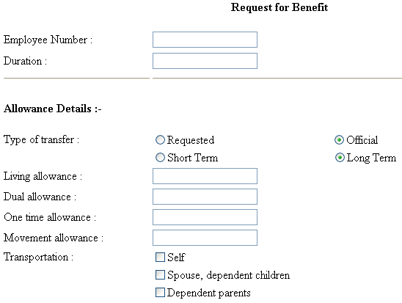
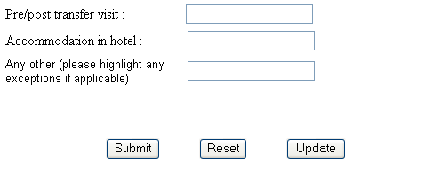

The Project Can be developed using either two tiers or three tiers Architecture.

Three-Tier Architecture:
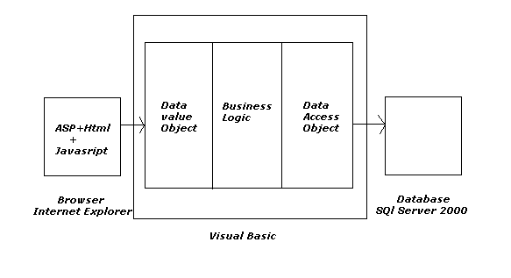
The Front-End is Asp.
The Back End is SQl Server 2000.
The Middle layer consists of the following objects:
- Data Value Objects.
- Business Logic objects.
3) Data Access Objects.

Two-Tier Architecture:

1) Front-End: ASP
2) Back-End: SQLServer

Steps to start-off the project

The following steps will be helpful to start the project.

- Study and be comfortable with technologies such as

  - Active Server Pages/HTML and SQL server and Visual Basic. Some links to these technologies are given in the ‘Guidelines and References’ Section of this document

- Decide The format of the various transfer Related documents Like Transfer Letter, Relieve Letter etc.
Requirements:

Hardware requirements:

Number | Description | Alternatives (If available)
1 | PC with 2 GB hard-disk and 256 MB RAM | Not-Applicable
2

Software requirements:

Number | Description | Alternatives (If available)
1 | Visual Basic 6.0
2 | SQl Server 2000 | Oracle 8
3 | Windows 2000 | Alternatively, Windows 98 with IIS Server Installed.

Manpower requirements:
Project Duration: 3months
Project team-size: 5-6

Milestones and Timelines

Number | Milestone Name | Milestone Description | Timeline  Week no.  from the start  of the project | Remarks
1 | Requirements Specification | Complete specification of the system (with appropriate assumptions) including the information to be present in the Transfer Related Documents. A document detailing the same should be written and a presentation on that be made. | 2-3 | Attempt should be made to add some more relevant functionality other than those that are listed in this document.
2 | Technology familiarization | Understanding of the technology needed to implement the project. | 4-5 | The presentation should be from the point of view of being able to apply it to the project, rather than from a theoretical perspective.
3 | Database creation | A database of at least 100 entries of employees of all grades should be created. The number of mail-ids to be created need not be 100. It can be around 10 to 20.A Database design document should be made. | 5-7 | It is important to finalize on the database at this stage itself so that development and testing can proceed with the actual database itself.
4 | High-level and Detailed Design | Listing down all possible scenarios (like Entering Transfer information, Searching Transfer Record based on several criteria) and then coming up with flow-charts or pseudo code to handle the scenario. | 7-9 | The scenarios should map to the requirement specification (i.e., for each requirement that is specified, a corresponding scenario should be there).
5 | Implementation of the front-end of the system | Implementation of the main screen giving the login, screen that follows the login giving various options, screens for each of the options (transfer request, transfer approval etc). | 10-12 | During this milestone period, it would be a good idea for the team (or one person from the team) to start working on a test-plan for the entire system. This test-plan can be updated as and when new scenarios come to mind.
6 | Integrating the front-end with the database | The front-end developed in the earlier milestone will now be able to update the employee transfer records database. Other features like mail notification etc should be functional at this stage. In short, the system should be ready for integration testing. | 12-13
7 | Integration Testing | The system should be thoroughly tested by running all the test cases written for the system (from milestone 5). | 14-15 | Another 2 weeks should be there to handle any issues found during testing of the system. After that, the final demo can be arranged.
8 | Final Review | Issues found during the previous milestone are fixed and the system is ready for the final review. | 16-18 | During the final review of the project, it should be checked that all the requirements specified during milestone number 1 are fulfilled (or appropriate reasons given for not fulfilling the same)

Guidelines and References

- http://msdn.microsoft.com/library/default.asp?url=/library/en-us/dnasp/html/asptutorial.asp (ASP tutorial)

- http://www.functionx.com/sqlserver/ (SQL-server tutorial)

- http://heather.cs.ucdavis.edu/~matloff/UnixAndC/Unix/CShellII.html (Shell script introduction)

- http://www.w3schools.com (Many Tutorials Available)

- http://www.4guysfromrolla.com

- http://www.vbworld.com

